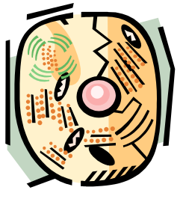
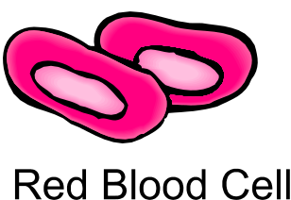
Cells

Scientists have been dissecting plants and animals for centuries to try and find out how they work, and answer some of the many questions we have about living things and, more specifically, ourselves. Over 300 years ago a scientist, Robert Hooke, first used the term ‘cell’ to describe the tiny building blocks observed in a piece of cork. We now know that cells are the basic units of all living things, and although their appearance, shape, size and purpose may vary, they are responsible for the functions that keep all organisms alive. So a cell is the smallest part that we can call life.

Give the meaning of the following words:
1. dissecting ________________________________________
2. specifically _______________________________________
3. term ____________________________________________
4. tiny _____________________________________________
5. basic ____________________________________________
6. purpose __________________________________________
7. vary _____________________________________________
8. functions _________________________________________
9. organisms ________________________________________

Which words or phrases can be replaced with the following:
- cutting open ______________________________________
- function _________________________________________
- many years _______________________________________
- in particular ______________________________________
- very small _______________________________________
- seen ____________________________________________
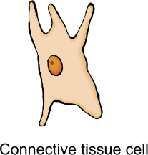
- differ ___________________________________________
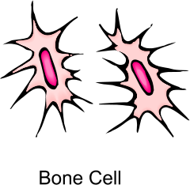

- How long is a century? ____________________________

- In which century did Robert Hooke first use the term cell?
_______________________________________________

- How do cells vary? _______________________________

- What is the function of cells?________________________
________________________________________________

